
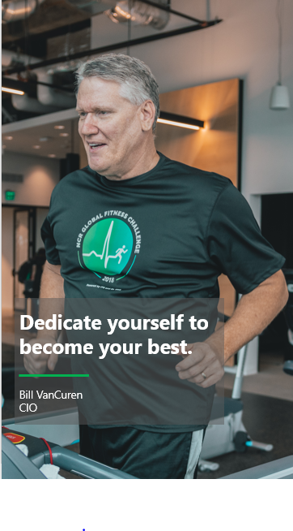

Bil l VanCuren

Executive Consultant & Board Advisor

Bill VanCuren is a global business executive and board member who leads transformations for growth through a balance of technology and business solutions, from private to publicly traded, from mid-size to multibillion-dollar corporations. Bill is an insightful business leader who leads teams through uncertain times, drives execution, and is always at the confluence of human factors and technology introduction.

Bill’s coaching skills and experience includes building diverse teams with culture that respects individuals while achieving aggressive corporate goals for profit and expense discipline. Bill is also a mentor to other CIOs and technology professionals in Atlanta as well as across the U.S. He excels at both one-on-one coaching and group sessions based upon experiential learning and adaptive real world case studies. Bill uses situational leadership techniques to demonstrate how to apply the best style to the situation.
Adjunct Professor: Bill has performed as guest lecturer at Georgia State University Masters program, Georgia Tech Scheller College of Business MBA program and The University of Georgia Terry College of Business. Bill also teaches MIS for business majors at University of North Georgia Cottrell College of Business. Bill also provides guidance for the InspireCIO Next Generation Leader(NGL) program and TAG’s Pathways to Leadership.

Career Highlights
- Led the successful Fortune 500 corporate re-location from Ohio to Georgia and also established a technology enabled GHQ campus in midtown designed for innovation & collaboration to enable the 2000+hdct workforce of a Software industry focused company.
- Developed & deployed technology to digitally enable large field service workforce (15K+ technicians) globally with advanced mobile devices, regional contact centers, and global parts logistics supply chains and digitized contracts representing $2B+ annual revenue.
- Led multiple successful M&A integrations, including three sizeable software companies each exceeding $300M in revenue, 2 now valued $1B/ each. One ATM operations company. This experience also includes a public company spin-off of a $2B data analytics software company, and “go private” assessments of parent company.
- Established Cloud first strategy and migrated majority of on-prem business systems to cloud based SaaS enterprise digital platforms supporting all mega processes across the entire company.
- Established first company CISO position and built a cyber security practice of >100 employees, continually improving security maturity scores while achieving FFIEC certifications and PCI & GDPR compliance.
- VP of Application Development leading move from build to buy strategy at time of Y2K cutover and achieved SEI CMM maturity to a level 3 in less than one year. Established large captive offshore development centers in India, shifting 70% of labor to low-cost and high productive delivery centers
- Three-time winner of Company level Outstanding Achievement award, one for Field Services innovation and twice for manufacturing systems.
- Achievement of highest engagement scores for all employees across the company 3+ years consecutively, during time of biggest cultur change coinciding with global HQ move
- Established the company relationships with non-profits that ultimately led to a more diverse workforce with established hiring pipelines, with community involvement at its core.

Areas of Specialization
- Coaching and Mentoring. One-on-one personal coaching and development for CIO’s and senior level technology leaders that enables identifying one’s leadership style and strengths and building competence and skills through situation-based leadership dialogue and techniques, and improving executive presence and presentation.
- Executive Presence & Interactions: Conducting effective meetings. Preparing compelling business cases. Presenting and captivating the executive or board level audiences.
- Education: Learning sessions focused on key aspects of the technology executive’s role that are designed to equip participants with the knowledge and skills necessary to be successful in their current role and positioned for growth to senior levels.
- Innovation Culture & Technology Leadership: Establishing a culture of trust and inclusion, especially for innovation and technology development organizations. Showing the way to a collaborative work environment that optimizes communication and alignment to objectives.
- Operational Excellence: This spans 14 yrs. of public board experience, CxO relationships, strategic & operational planning, and performance measures & KPI’s. Creation and presentation of strategic and operating performance improvement plans.
- Information Technology Governance & Management: Emphasis across financial (opex & capex), human resources, program/project management, supplier/vendor management, offshoring/outsourcing, systems analysis & business process design., & TBM.
- Organizational leadership and transformations: Innovation, culture change, organizational design, alignment to business models for various sized companies or divisions. .
- Mergers and Acquisitions: Due diligence from selection thru integration phases. Methods for managing and measuring financial and business process integrations
- Technology Partner & Ecosystem Management: Includes formation of exec level relationships, Technology company Advisory Board roles (10+ years), Business review structures, and product level contract and cloud integration leadership for SW and SaaS providers.
- PE Advisory. Assist private equity firms with the development and execution of information technology strategies that are aligned to support achievement of the company’s goals and objectives. Conduct system inventory and risk assessments, and evaluate teams and talent required for digital transformation.

Unique Attributes
- Board Experienced: Bill was actively involved in the Audit Committee and Risk Committee of the Board of Directors at a public company– attending more than 50 public board and committee meetings over his 12-year tenure as a Fortune 500 CIO. In addition, Bill has served as Advisory Board Chair for the two largest Atlanta technology associations, Technology Association of Georgia and Georgia CIO Leadership Association.

- Education: Bill holds a B.S. degree in business administration from The Ohio State University Cum Laude, with concentration in Computer Science, and an M.B.A. from The University of Dayton, along with executive education completed at Stanford University.

- Thought Leader: Bill has been interviewed and published on Leadership and culture change topics related to Information technology in leading periodicals such as WSJ, Fortune, and IDG and has been recognized in the CIO top 100 and Information Week top 500.

- Awards: Bill was named CIO of the year in 2011, Techbridge CIO Philanthropy leader in 2018, and HMG’s Tech Execs to Watch in 2019, along with the Lifetime Achievement Award in 2022 when he also chaired the first annual InspireCIO National Orbie Awards.

- Adjunct Professor: Bill has performed as guest lecturer at Georgia State University Masters program, Georgia Tech Scheller College of Business and University of Georgia Terry College of Business and teaches MIS for business majors at University of North Georgia Cottrell College of Business.

- Green Belt 6 Sigma, certified by ASQ

- Boardroom Certified Quality Technology Expert (QTE) – Digital Directors Network

Interests;

Hobbies
Hiking, snow skiing, landscaping

Food
Taco Mac wings

Band
Credence Clearwater Revival & Led Zepplin

Movie
Patton

Super Power
Inspiring Individual Performance

TV Show
Suits (NetFlix)

Book
The World is Flat, by Thomas Freidman

Quote
“The mountains are calling and I must go.” – John Muir

